SUBTRACTION PROBLEMS
KS1 – 2001 Paper
1.
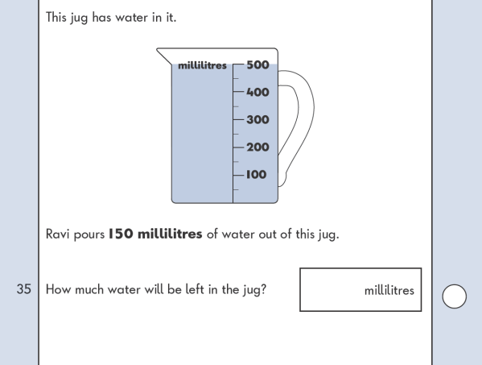
KS1 – 2002 Paper
2.
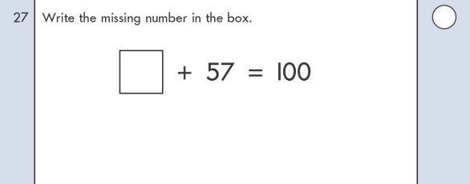
KS1 – 2003 Paper 1
3.
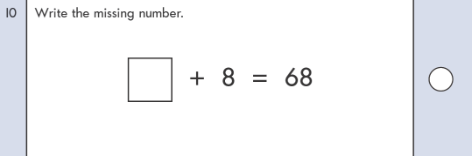
KS1 – 2003 Paper 2
4.
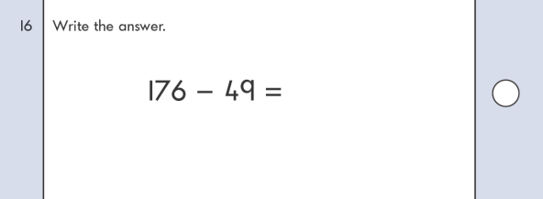
KS1 – 2004 Paper 1
5.
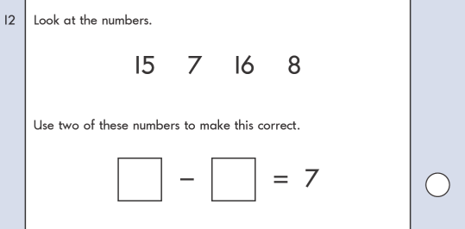
6.
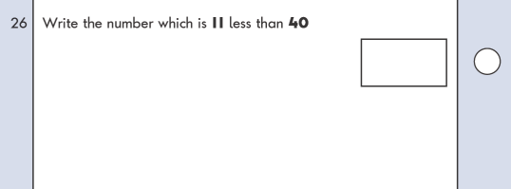
KS1 – 2004 Paper 2
7.
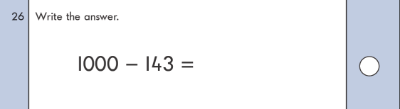

KS1 – 2005 Paper 1
8.
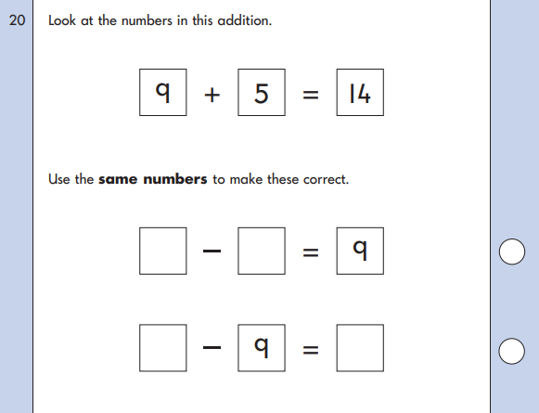
KS1 – 2005 Paper 2
9.
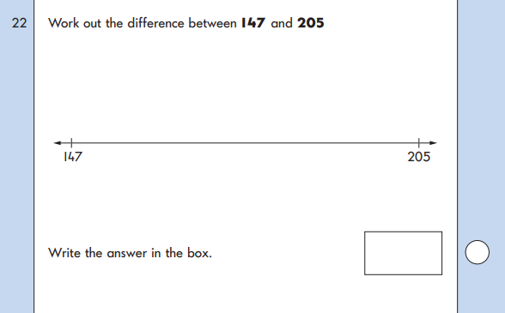
10.
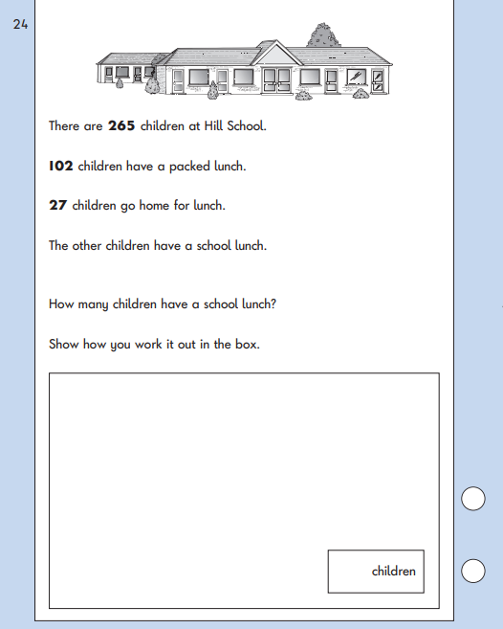
KS1 – 2009 Paper 1
11.

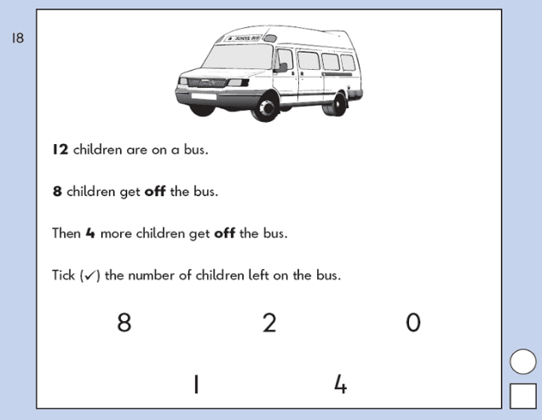
KS1 – 2009 Paper 2
12.
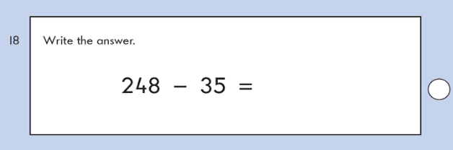
13.
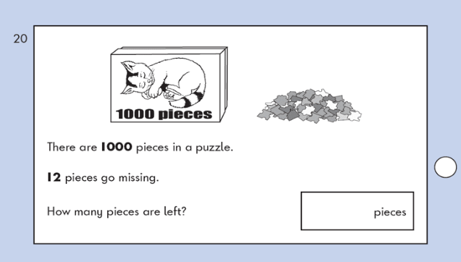
14.
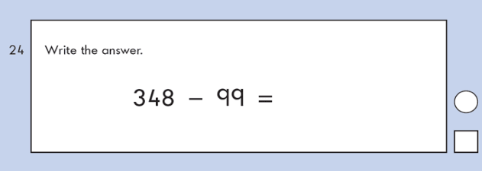
KS1 – 2016 Paper - Arithmetic (Second)
15.

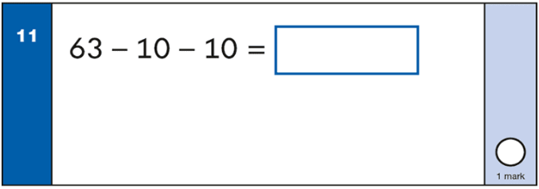
KS1 – 2016 Paper – Reasoning (Second)
16.
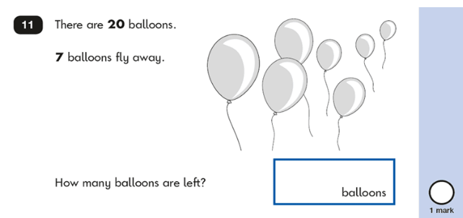

KS1 – 2016 Paper – Reasoning (Second)
17.

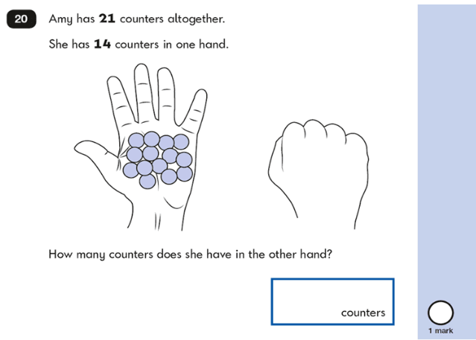
18.
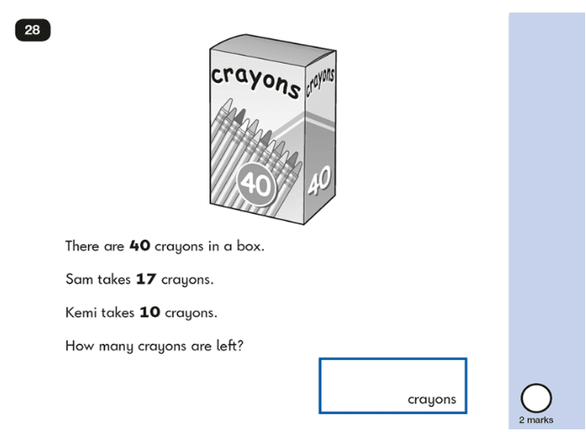
19.
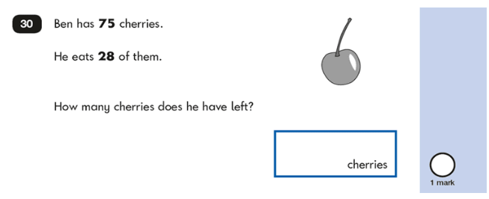

KS1 – 2017 Paper – Reasoning
20.
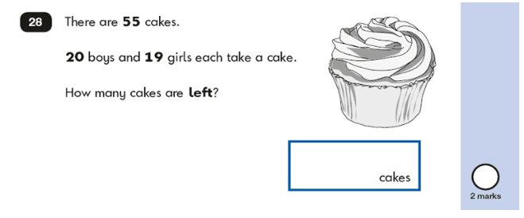
21.
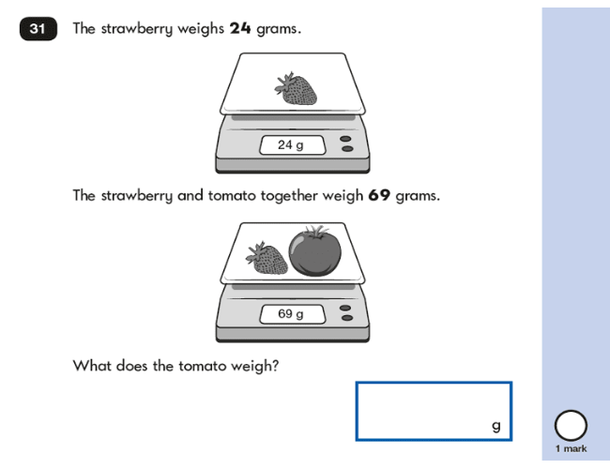
KS1 – 2018 Paper – Reasoning
22.
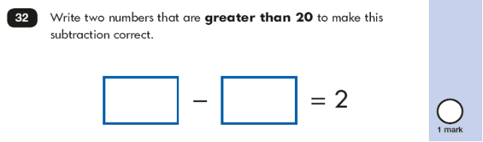
KS1 – 2019 Paper – Reasoning
23.
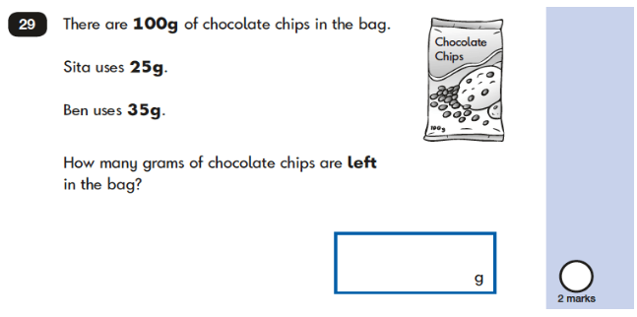
24.
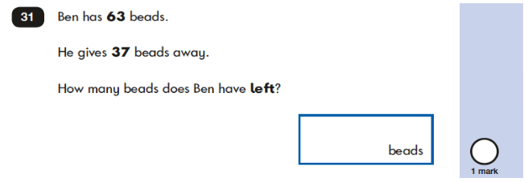
KS1 – 2022 Paper – Reasoning
25.
